Let's compare different OS for smartphones: Brand or functionality?
Nowadays smartphones became an integral part of our lives. This small device contains all the information we need; it’s an enormous storage with amount of abilities. These abilities, their quality and spectrum depend on which operation system you choose. Commercials convince us that this or that OS is the best for us, but who knows? So, be attentive, when you come to shop and start comparing devices. If you don’t want to make wrong choice, read these pros and cons of the most popular operation systems.

Windows:
+ Microsoft Office is available and very easy in use
+ it’s brainchild of independent company
+ promptitude of OS
+ design is simple but creative
+ you can change the size of icons and create extraordinary menu
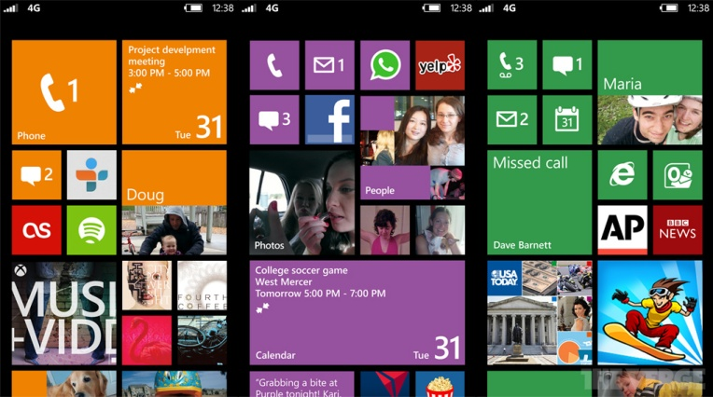
-OS is unfinished and not completely debugged
-not all off apps can be found in store; sometimes the reason is that some of them are not available for Windows; now company creates their own similar apps but they still have disadvantages
-from the very beginning smartphone is almost empty, you should download many things
-in a very few models internal storage can be cleaned; cache, cookies and other junk files can’t be removed, so, the memory can be filled very fast
-updates weight a lot, sometimes even more than free memory that you have

Android:
+ OS is very simple and comfortable in use
+ amount of apps that give you a lot of possibilities in smartphones’ exploitation
+ all the content can be synchronized with Google service; it allows the users keep information on their own accounts, so, in case of breakage of device all media and the other info won’t be lost
+ Google service proper; there are many useful potentialities that you can exploit, they don’t have special demands
+ some programs in Google play are one of the best alternatives of photo editor, for example
+ extraordinary interface which you can change if the previous one bored you
+ OS has its own document editor, Polaris Office
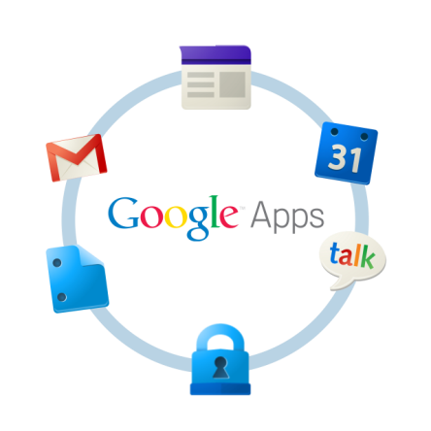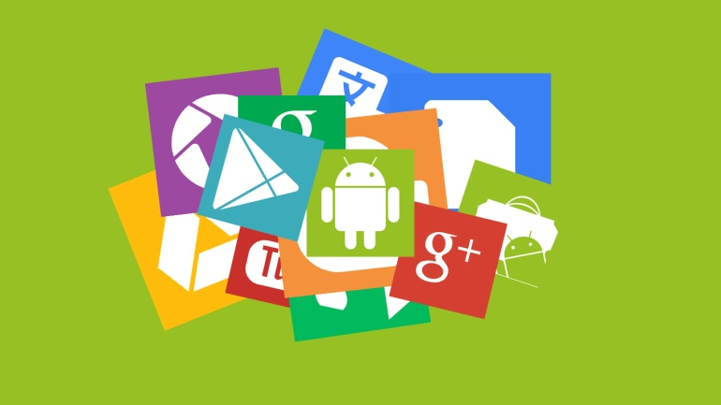
- old smartphone models don’t support some apps and other possibilities of the OS
-battery runs down too quickly in case of using 3G; if you don’t need it, you’d better switch it off; also, you can save the battery by bringing down the brightness, it’s available in every OS
-malfunction of some apps because of pirate versions or defects

iOS:
+ high quality of the photos
+ the promptitude of apps that demand net-connection
+comfortable interface, beautiful design
+great amount of useful apps
+battery usage is very long in case of listening to music
+the Apple ecosystem
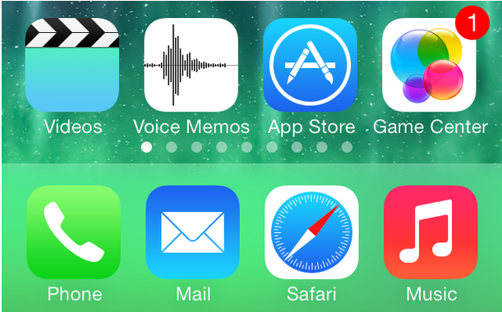
-battery runs down quickly if you use many apps
-interface in the last version, iOS 7, became worse
-lack of Bluetooth
-it’s a closed platform

BlackBerry:
+it’s more appropriate thing for business users because the battery consumption is very optimal
+according to the researches Blackberry is reliable hardware, its longevity and durability are on the highest level
+comfortable keyboard
+promptitude of the OS
-battery life is strong not in all models
-lack of apps
-there are no upgrades to BB10
-Web browsing leaves much to be desired
